Function Flow

Block Diagram:

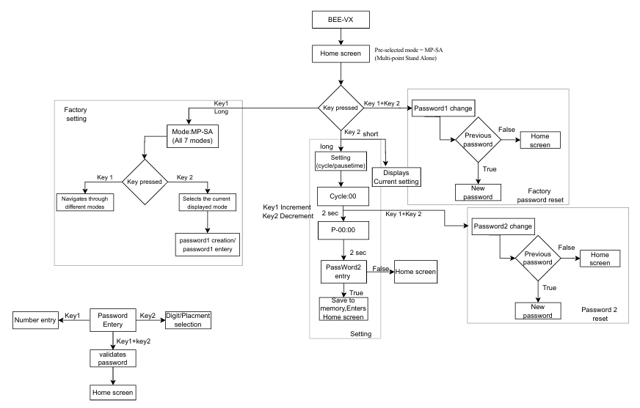

The system is provided with 2 keys and 3 LEDS
- Keys
  - Selection keys
  - Navigation keys
- LED
  - Green- Motor LED- motor run indication
  - Amber-Pause LED- mode pause indication
  - Red- Fault LED – Fault indication

INITIAL SCREEN:
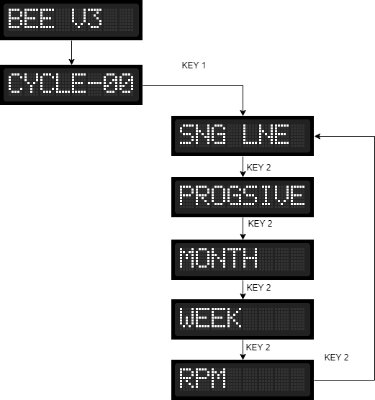

Initially: The system retrieves the previous mode and check for the home position Where the screen will display number of cycle from previous/Default mode
Action:
On pressing the key1 the display changes to “SNG LNE” mode, here if the key2 is pressed
user will navigate through different mode, if key 1 is pressed on selecting the required mode, then the user will enter that particular mode. If no key is in action, it will return back to the home screen.

SINGLE LINE MODE:
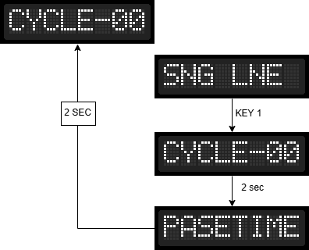

Entering Single Line Mode:
    - On pressing the key 1 will make the user enters the “SGN LINE” mode.

Functionality with in Single Line Mode:
    - When the system is in SGN LINE mode, pressing Key 1 changes the display to "CYCLE-00".
    - The user can then set the desired number of cycles.
    - After 2 second of confirming the cycle count, the system automatically enters the Pause Time setting mode.
    - After 2 seconds of setting the Pause Time, the system automatically saves this setting and enters the RUN time (after sensing the Home sensor).

Function in each Mode:
- Cycles-
In this mode, the user can set the number of cycles using increment (key 1) and decrement (key 2) keys, if no key is in action for 2 second the screen changes to “PASETIME” then after 2 seconds, screen changes to “CYCLE-00” (home screen/Run time).
- Pause time-
In this mode the user can set the pause time using increment (key 1) and decrement (key 2) keys if no key is in action for 2 second the screen changes to “CYCLE-00” (home screen/Run time).

PROGRESSIVE MODE:
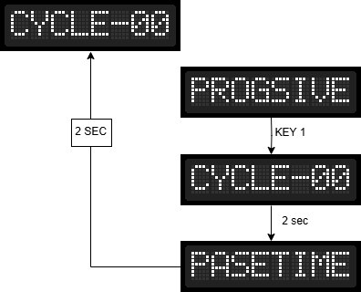

Entering Progressive Mode:
    - On pressing the key 1 will make the user enters the “PROGSIVE” mode.

Functionality with in Progressive Mode:
    - When the system is in PROGRESSIVE mode, pressing Key 1 changes the display to "CYCLE-00".
    - The user can then set the desired number of cycles.
    - After 2 second of confirming the cycle count, the system automatically enters the Pause Time setting mode.
    - After 2 seconds of setting the Pause Time, the system automatically saves this value and enters the RUN time.

Function in each Mode:
- Cycles-
In this mode, the user can set the number of cycles using increment (key 1) and decrement (key 2) keys, if no key is in action for 2 second the screen changes to “PROGSIVE” then to “CYCLE-00” (home screen).
- Pause time-
In this mode the user can set the pause time using increment (key 1) and decrement (key 2) keys if no key is in action for 2 second the screen changes to “PROGSIVE” then to “CYCLE-00” (home screen)

WORK IN EACH MODE:
- SINGLE LINE MODE: INPUTS:
  - CYCLE: The user specifies how many cycles the system should complete
(maximum cycle:50).
  - PAUSE TIME: The user sets the duration for which the system will pause after completing given number of cycles

CYCLE EXECUTION:
  - The cycle begins from the Home Position.
  - The motor starts moving forward.
  - Upon sensing the Stroke Sensor, the motor reverses direction and moves backward until it senses the Home Sensor.
  - This cycle repeats for (N - 1) cycles, following the same forward and reverse pattern.
  - In the Nᵗʰ cycle:
    - The motor moves forward.
    - When the Relief Sensor is sensed, the system enters Pause Time.

PROGRESSIVE MODE: INPUTS:
  - CYCLE: The user specifies how many cycles the system should complete.
  - PAUSE TIME: The user sets the duration for which the system will pause after completing given number of cycles

CYCLE EXECUTION:
  - The cycle begins from the Home Position.
  - The motor starts moving forward.
  - Upon sensing the Stroke Sensor, the motor reverses direction and moves backward until it senses the Home Sensor.
  - This cycle repeats for N cycles, following the same forward and reverse pattern. Then enters the pause time

LED INDICATION:

LED COLOUR | Description
GREEN LED | MOTOR RUN Indication
AMBER LED | MOTOR PAUSE Indication
RED LED | FAULT Indication

